This report details the evolution of the NetSense social network over a 45 week period from August 2011 – May 2012. The data are based on information collected from smartphones on who texted and called who during this period. It is supplemented with survey data.

Study Design

The study was designed to give 200 first year students at one university smartphones through which we would gather information on their texting and calling communication events (and other information). The selection design for recruiting participants involved selecting 4 residence halls, 2 male and 2 female, from among the 29 residence halls at this university, and trying to recruit as many first year students in these dorms as we could. Then we opened up the recruitment to first year students in all the other dorms. As a result we have more participants in 6 of the dorms.

The design can be viewed as sort of an experiment without an intervention. Prior to arriving on campus participants had no contact with anyone else in the study. They are allocated at random to dorms and dorm rooms, albeit with the provision that men can only reside in male dorms, women in female dorms. So we begin with a set of nodes (vertices) and no edges, and random allocation to dorms and rooms within dorms.

We logged through the smartphones all communication events, including both receiving and sending of texts and voice calls. Each communication event includes information on the sending and receiving phone number, the time and date when the event began, the type of event (SMS or call), and in the case of phone calls their length. No content is captured.

The focus of this report is on communication events involving text or voice calls between the 183 first year students who we given smartphones. While we gave smartphones to 197 people, some dropped out early in the study, others rarely if even used their phones, and a few others never communicated with anyone else in the study. As a result, over the 45 week period we have data on the communication events between 183 students who made (or received) at least one call or text to (or from) another person in the study.

It should be noted, that we do have information on calls and texts that were made or received by our participants to people outside the study, either other students at the university, or other people. But for this report we focus just on the evolution of the social network among these 183 students.

Table 1 gives the distribution of these 183 students across the 29 dorms by the number of participants in the dorm. Four dorms, two male and two female dorms, have 75 of the 183 participants (41%). In terms of gender, around 54% of the active participants are men.

Number of Participants in a Dorm | Number of Dorms with that N participants
27 | 1
18 | 1
15 | 2
9 | 1
7 | 2
6 | 4
5 | 3
4 | 6
3 | 5
2 | 3
1 | 1
Total N of Dorms | 29
We collapse over time (into 5-week intervals) to get counts of the number of times two of these 183 people communicated with each other. In this report we treat these interacting pairs as non-directed edges and ignore the information on who initiated the text or call. The counts of the number of interactions are the measures of the strength of an edge in a given time period. We also collapse a vertex’s edges in order to measure nodal degree, that is the number of people a person communicated with in a given time period. From the node level data we also compute other ego network measures such as a person’s clustering coefficient.

The overall 45 week period is divided into 9 5-week periods in order to look at the evolution of the network.

In addition to the communication data, we obtained survey data from participants prior to their arrival on campus and then during the Winter Break and again in May at the end of the academic year. For this report we have only looked at the following nodal traits: gender and residence hall.

Table 1: Distribution of Dorms by
Number of Participants in Each Dorm

The Evolution of the Network: Global Properties

Table 2 reports statistics on the network for the overall 45 week period (first data column) and then for each of the 9 5-week intervals. As note above, the number of vertices for the entire period is 183, but in any given 5-week period the number is smaller, ranging from 169 in the first 5 week period to only 76 during the last 5 week period (which occurred as students were leaving or had already left campus). The number of edges during the entire 45 weeks period is 514. This is out of 16,653 possible pairs of students indicating we have a very sparse network with a density of around 3%. However, the number of edges also varies over time from 252 in the first 5-week interval to only 61 edges in the last time period. However the density of the network in a given 5-week period is fairly constant at around 1.9%, though it drops off significantly in the last 5-week period. These 5-week figures are probably a more reliable estimate of the network density given that the overall figure of 3% is based on the cumulative number of edges and therefore includes edges that have “died” (i.e. occurred in one or a few of the time period, but not subsequently – more on this later).

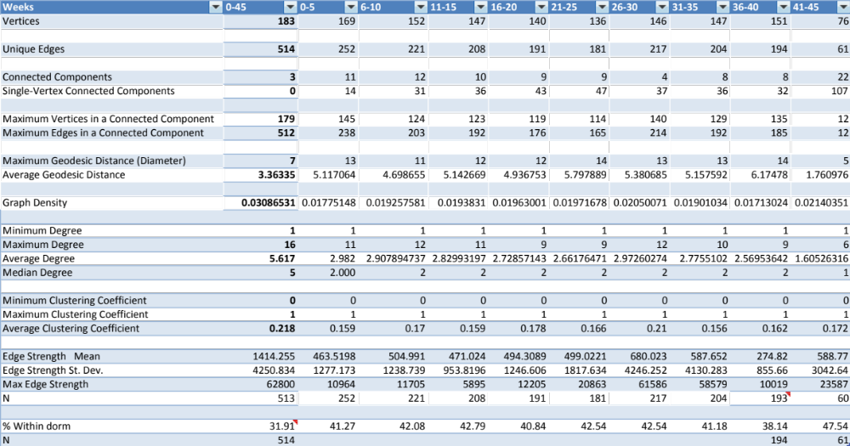
Table 2: Network Statistics Over Time

For the full period there are 3 connected components, and the largest connected component includes all but 4 vertices and 2 edges. However, in most of the 5-week intervals there are substantially more components, though in weeks 26-30 the graph becomes more connected and there are just 4 components.

The degree distribution for the entire 45 week period is skewed with an average degree of 5.6, but a median of 5 (see Figure 1). Again, many of these edges appear only in one or a few of the 5-week intervals, so the average degree during a typical 5 week period is lower at around 3. The maximum degree for the entire 45 week period is 16, though in any 5-week interval the maximum degree is 12. There are significant numbers of people with a degree of 1 or 2, and as already some with a degree of 0 in a given 5-week interval.

The average clustering coefficient is .218, but varies across 5-week intervals from .16 to .2. Given that these clustering coefficients are computed on all vertices including those with just a degree of 1, they should be treated with caution.

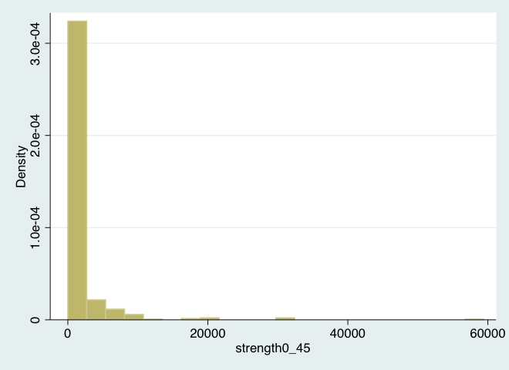
Finally, the network can be described in terms of the distribution of the strength of the edges in it. Strength (S_{ij}) is defined as the total number of communication interactions between two vertices in a given time period (S_{ij} = m_{ij} + m_{ji}). For the full 45 week period the average strength of the 513 edges is 1414, indicating about 31 communicate events per week for the “typical” edge. However as seen in Figure 2, the distribution is very skewed (the median is 170), and many edges are quite weak .When we look at the 5-week intervals, the average strength varies from 463 events in the first five week period to around 680 in weeks 26-30. This is also the 5-week interval when the density was the highest and where the graph was more connected.
Figure 2: Distirbution of Edge Strength for 45 Week Period

Edge Evolution

It is clear from the difference between the cumulative number of edges (514) and the totals for each of the 9 5-week intervals, that there are a significant number of edges the form and then die (or at least become dormant). This is clearly seen in Table 3 which groups edges by the number of 5-week intervals in which it appears.

Almost two-thirds (63.23%) of the edges only appeared in 3 or less of the 5-week intervals. These are edges which either survived for 15 weeks or less (indicative of the liability of newness of ties), or appeared and disappeared, leading to an intermittent pattern. We need to investigate these more.

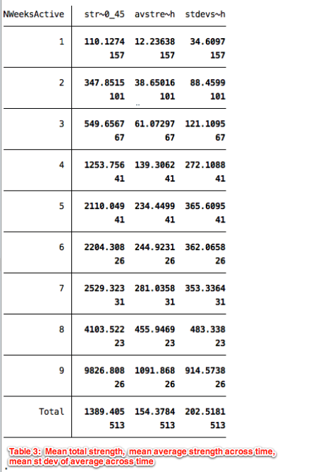
Most of the other one-third of the edges are “continuous” edges (i.e. not intermittent), even though most do not appear in every 5-week period because they either formed later in the academic year and/or they did not persist until the end of the year. Inspection of the data indicated most of these edges are continuous when they appear in 5 or more of the 9 5-week period. More intermittent ties were evident among the edges that appear in just 4 of the 5-week periods. There is a strong relationship between the total number of 5-week intervals a tie appears in and the average strength of the tie, as seen in Table 4. The numbers in the second column show how the total amount of interaction between two people is lower, as one would expect, the fewer 5-week period in which the tie has been active. These numbers should be recomputed by dividing by the number of weeks active (or number of 5-week periods active), but a rough estimate is obtained by doing the division yourself.
The average in the third column is the average over time periods, while the last column gives the st. dev. of that average, and indicator of how stable the average is over time.
Table 4: Total strength and average strength (across time)

What these tables seem to indicate is that there are lots of edges that form, never strengthen, and either become dormant and possibly reappear again or disappear for good. However there are some edges that persist and as they persist they increase in their strength. One of our tasks will be to predict which ties fall in which of these groups.
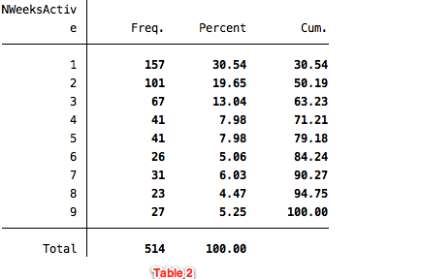
Within and Between Residence Hall Edges

One of the interesting patterns concerns whether an edge is within a residence hall, or between two of them. Of the 514 edges, about 32% are within a dorm. The last row in Table 2 shows the percentage of edges during a given 5-week period that were within a dorm. They are fairly constant around 41-42%, though in weeks 36-40 there is a drop, and then in weeks 41-45 a large increase (showing that ties within dorm are more active while away, at least for the first few weeks of summer vacation). What is interesting is that for the full 45 weeks period, the percentage of within dorm ties is 32%, indicating that ties between dorms are more likely to be short lived. This is seen in Table 5 which indicates the percentage of edges that are within a dorm by the number of 5-week intervals in which the tie is active.
Table 3: Distribution of Edges by Number of 5-Week Periods in Which Edge Appears

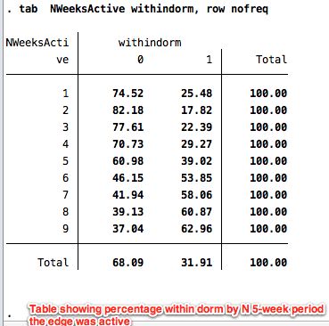
As this table indicates, over three-quarters of edges that were active in 3 or less of the 5-week periods are between dorm ties, while around 60% of edges that were active in 7 or more of the 9 5-week periods are within dorm ties. This indicates that ties that have been active for more time periods tend to be within dorm ties.
Table 5: Percentage of Edges That Are Within Dorm Ties by Number of 5-Week Period That the Tie is Active

What is a bit surprising is that the average strengths of edges is not all that different for ties within vs. between dorms (means of 1585 within vs. 1335 between). This could be because there are weak ties within dorms with few participants, but this needs to be explored more.

Network Visualization

We visualize the evolution of this network over the 45 week period using NodeXL, an add-on for Excel. To focus attention on change in vertex degree and edge strength, as well as to show the appearance and disappearance of edges and vertices over time, we fixed vertices in Cartesian space by grouping together vertices which are in the same dorm using NodeXL’s grouping algorithm. The first panel in the upper left hand corner of Figure 3 depicts the full network over the 45 week period and includes all the 514 edges and 183 vertices, while subsequent blocks depict the network in each of the 9 5-week time periods. In the first panel, bold lines separate vertices that are in the same dorm, and those vertices have the same color. In subsequent depictions the bold lines are omitted. Squares indicate women, and therefore square vertices that are grouped together indicate a female dorm. The depiction shows that there are four dorms in which we have more vertices. It also shows that while in a couple of these dorms there are strong within dorm ties, not all the within dorm ties are strong, and many of the stronger ties seem to span across dorms. There are also some vertices that seem to vary significant over time in their degree. And while there are some strong edges that appear in all the time periods, many of the edges also vary in their strength over time. Finally the depictions seem to indicate that there is variation over time in the overall level of activity. Clearly during the last time period there is much less activity, but this seems to be also true, to a lesser extent, for some of the other time periods.

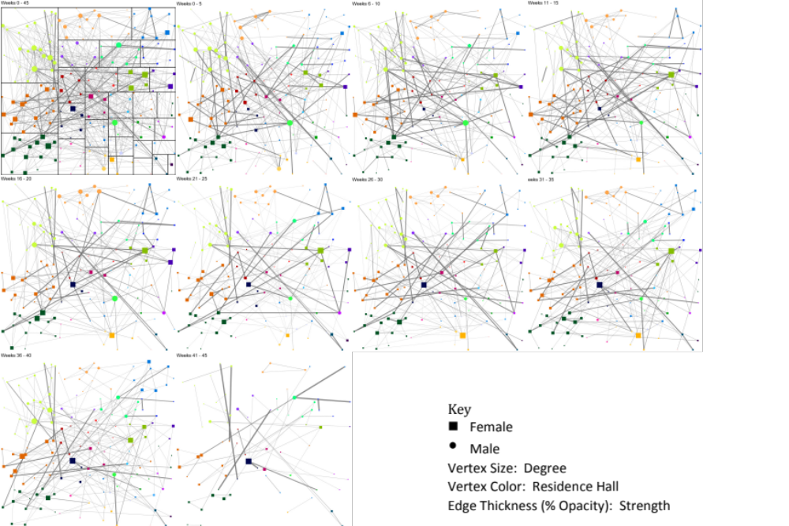
Figure 3: Evolution of Network Across 9 5-Week Time Periods

One case is omitted, an outlier with a value of 459014
I redid this at a higher resolution, i.e. number of actual weeks the edge was active. Less than 10% of ties were active for 23 or more of the 45 weeks.

