This report details work done to distinguish different types of edges in the NetSense edge list data derived from NetSense subject communication events over the last year. The purpose in distinguishing edge types is to distinguish between edges that existed prior to our subjects coming to ND and those that were formed after coming to ND. Using mulitiple other sources of data, we are able to distinguish for roughtly 50% of the total edges whether they involve Family, were PreND, or PostND edges. After categorizing edges we can then compute each subjects nodal degree for each edge type, and therefore examine correlations between the different components (e.g., is having more preND ties associated with increases or decreases in the number of postND ties) and the composition of people’s networks. The next step is to make this analysis more dynamic by computing degree for various types of relationships at various points in time since arrival at ND. But the first step is to derive these measures for the full data set.

We begin with an edge list of 40,738 edges generated by the use of the cell phones of 186 NetSense subjects over a 60 week period. This edge list was generate by Penta on 10/12/12 and is called “Frequency - weekly frequency between dyads with Alter list data.dta.” The Stata program “CreateTypeVarsAndExport.do” is the code that creates the edge type variables and then exports a set of .xlsx files to be processed by NodeXL in order to generate edge lists. A listing of created vars (as well as some of the input vars) can be found in the “AlterEdgeDegreeCodebook.xlsx” spreadsheet/codebook. These variables are created based on information from other sources besides the communication event data and are linked to the cell phone communication event data via the phone number. The other sources are:
- Three network surveys in which subjects were asked to list names, phone numbers of email addresses of 20 people with whom they interacted with in previous time period. Egos are asked about each named alter, including quesitons on gender, family status, and attendance at ND.
- Contact book from cell phones that contain email addresses allowing us to identify phone numbers that belong to ND students in various ways (same number appearing in 2 or more lists, ND email associated with phone number).
The full .dta file with the new created variables and all the variables in the dataset Penta created is called “Frequency - weekly frequency between dyads with Alter list data(DH2).dta”

Here is a brief summary of some of the key variables:
- nameind: indicates in which survey an alter want named by an ego. Used to identify edges where alter was named prior to ego coming to ND
- reltypesum: indicator of the type of the alter in terms of family, sign other, friend, acquaintance, etc. Allows us to identify family ties which existed prior to coming to ND
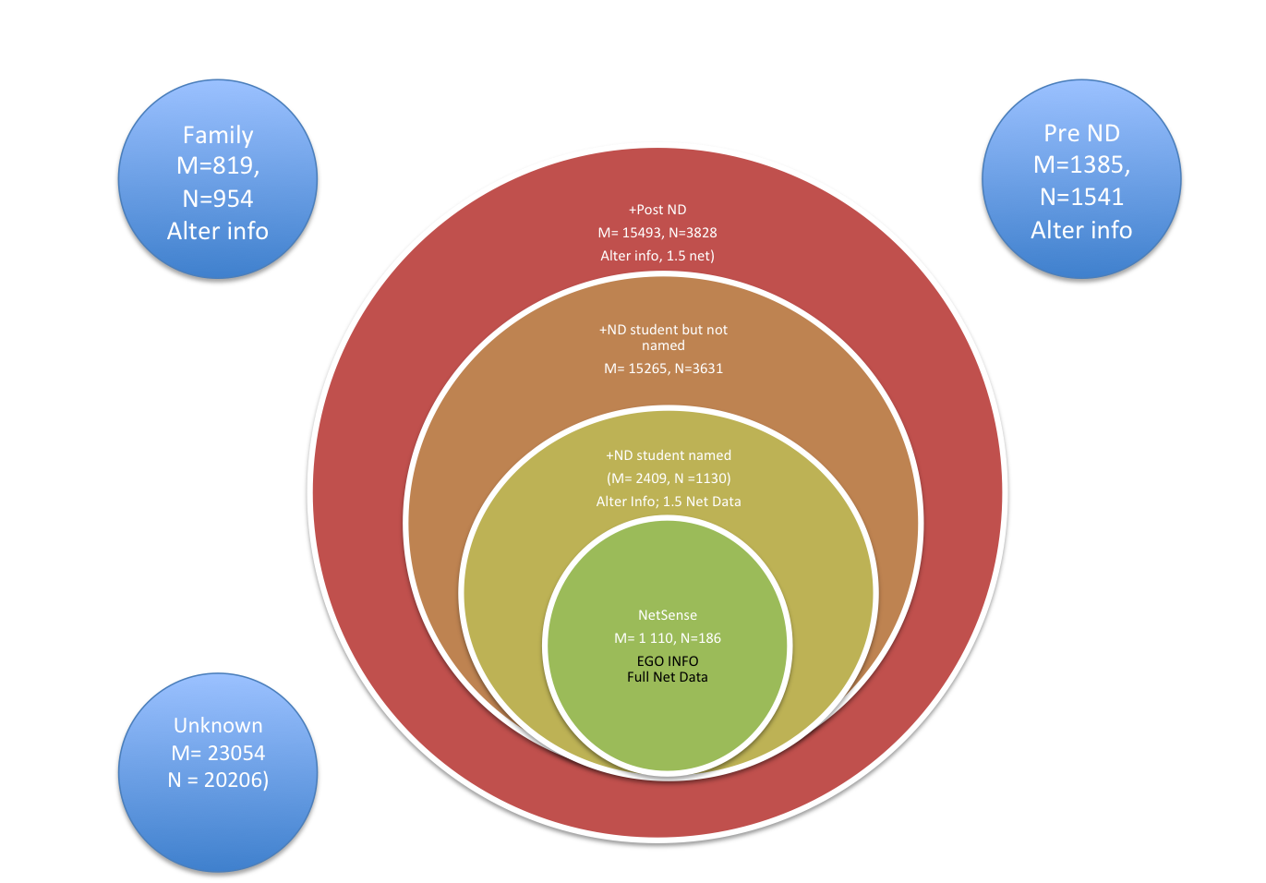
- PrePost set of variables: indicators of general status of alter in terms of whether pre or post tie and whether we have any information on the alter.

The various constructed variables detailed in the spreadsheet codebook allow us to create various subsets of the edgelist from which a degree list can be generated with NodeXL. The figure below details the logic.

See “SummaryDataN_M.xlsx” spreadsheet for more information on these networks

The core network in this study in NetSense Network consisting of 186 vertices (N) and 1110 edges (M) between them over this 60 week time period. With this network we have both information on the alters (because they are in the study), and full network data.

This network is embeded within a larger network which I call the Notre Dame Student Restricted Network. It includes both NetSense participants and ND students that our NetSense subjects named as ND students in at least one of the surveys. It includes 1130 nodes (of which 186 are NetSense subjects and 944 are named students) and 2409 edges (of which 1110 are from NetSense network and the others are between a NetSense subject and a named student alter) . None of these edges are between named alters (at this time). However we do have ego supplied data on connections among named alters, so potentially a 1.5 network can be generated. In this network we have information on all nodes, though the information on the alters (if not another NetSense student) are more limited and supplied by the ego.

The next network is called the Notre Dame Student (Expanded) Network. This includes 15265 vertices all of which can be identified in one way or another as ND students (i.e NetSense, named and identified by NetSense student, or via Penta’s methods). 12856 of these edges are between NetSense subjects and the new alters (N = 2501) identified with Penta’s indicator. We know nothing about these alters except that they communicated with one of the NetSense subjects and through various means can be identified as a ND student. Altogether there are 3631 nodes in this network (=2501+944+186). This is a very incomplete network in that we have no information on ties among the 2501 added alters, between these alters and named alters. We can however use information in this network to compute an estimate of each of our NetSense subject’s within-ND degree.

The final network in this series can be called the Post-ND Network. It includes the nodes and edges in the ND Student Network and in addition 228 edges and 187 nodes involved in those edges that are (1) named by an NetSense participant, but (2) not as a ND student and (3) not in the first time period. All together there are 15,493 edges among 3828 nodes. For some of this network there is information on the alter, and also the potential to identify ties among named alters.

There are three other networks. The Family Network consists of 954 nodes and 819 edges among them. 186 of these nodes are NetSense participants, the remainder are alters they listed as family members. All edges are between a NetSense participant and a family member, none are between NetSense subjects or between family members. This is a strange graph, but it does allow us to compute the degree of a NetSense participant with respect to family membership. This network does not overlap with the Post-ND Network except for the 186 nodes in the NetSense study which are in both networks. This is why it is shown in the Figure as separate from that network

The Pre-ND network consists of 1541 nodes (of which 186 are NetSense subjects, the remainder are alters an ego named in the first survey which was taken prior to arrival at ND). There are 1385 edges among 1541 nodes. Again this network is separate from the Post-ND network (and in fact existed prior to it in time).

The Unknow Network consists of the remaining 23,054 of the original 40,738 edges that we are have no information on other then the phone number obtained from cell phones indicating that a NetSense subjects communicated with that person. We include this network because it is part of the Full Network on which we want to compute a NetSense subject’s overall degree. The Full Network includes all the nodes (=25846) and edges (=40738, of which 26529 are edges from cell phone commmunication but which can not be identified in any way) mentioned above. It is used solely to compute the overall degree of each NetSense subject.

Based on this logic I then proceed to export an edge list of each of these networks. These edge lists are then imported into NodeXL which is used to generate a vertice list along with a nodal degree of each vertice and overall graph statistics.

The stata program “MergeNodeData.do” then merges all these vertice lists so that a .dta data file is generated that includes measures for each NetSense subject of how many alters they had of each type. These measures are presented in the “AlterEdgeDegreeCodebook.xlsx” codebook (the degree sheet) and include measures of a person’s overall degree and degree within various subnetworks (e.g., with NetSense subjects, with all post-ND alters, with family, with preND friends). Also included are percentage measures for each node giving the percentage (proportion) of its alters that are in each category.

It should be noted that the merged data file generated by this procedure, “NodeMaster8.dta”, has records for all the nodes, including those that are alters but never egos (i.e. are not in NetSense study). Most of the time we will just focus on the degree traits of the 186 NetSense nodes which can be selected by using merge_NDR = 3.

Analysis: Edge Data

First here are some descriptive statistics from the edge data on the different types of edges that we have

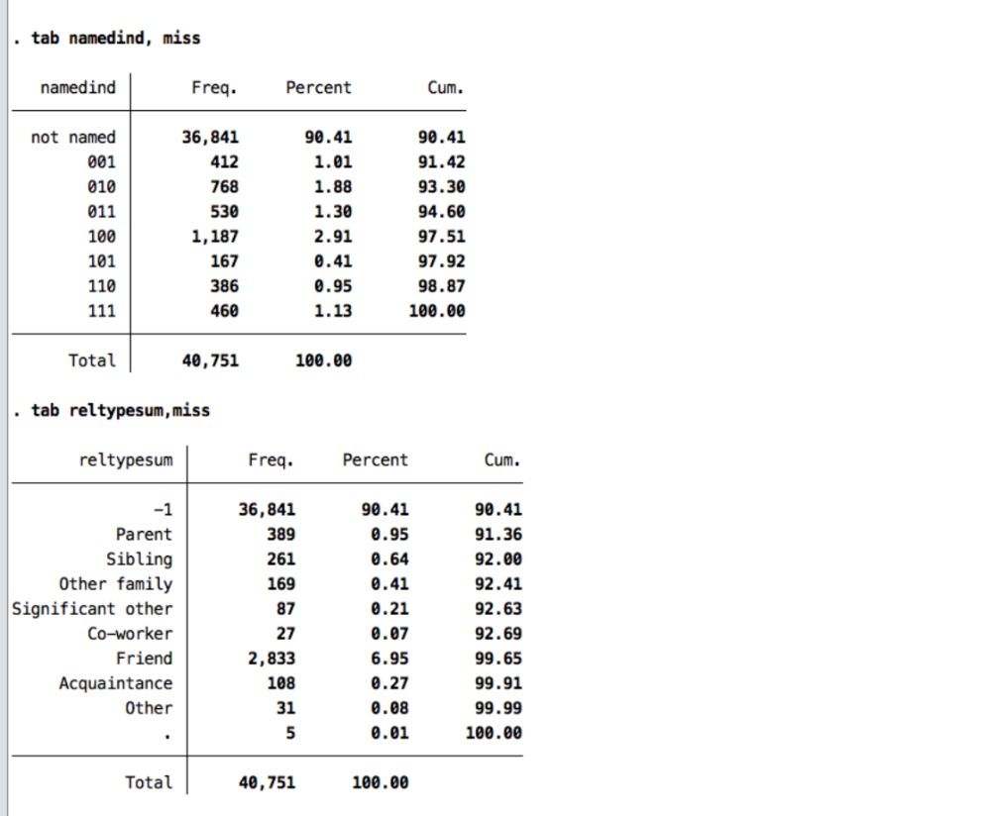

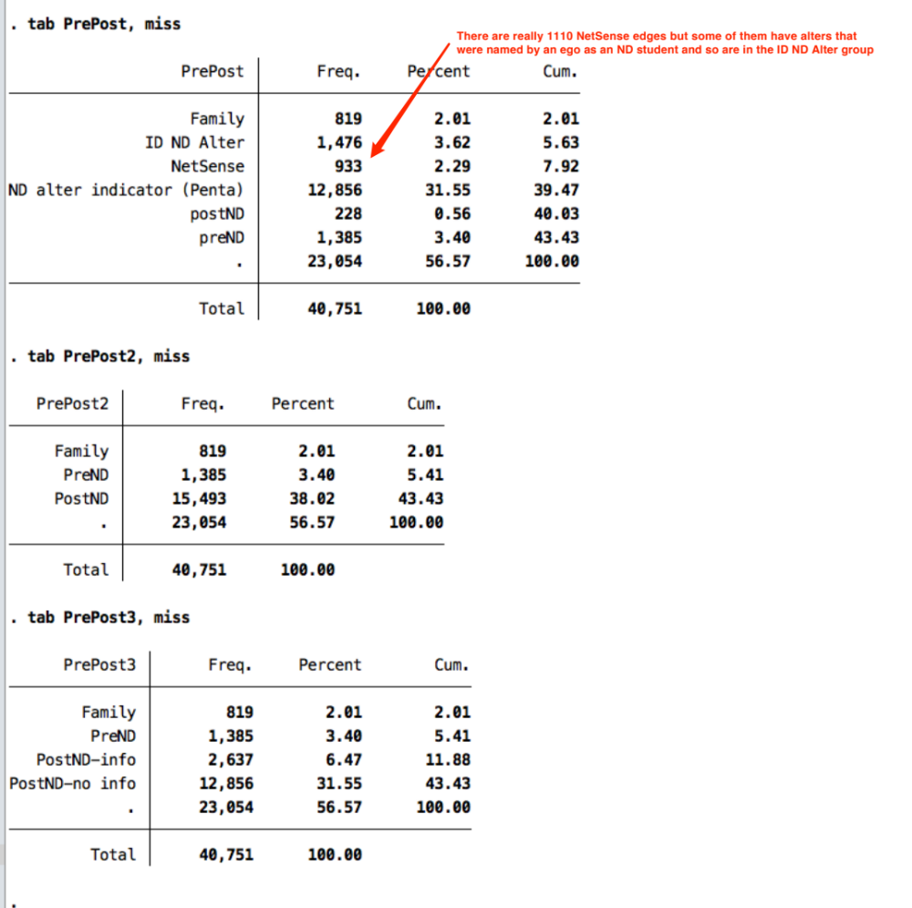

And here are some statistics giving the proportion of edges of various types that have appeared by a given week into the study. This only goes up through week 45, but most edges that we can identify have appeared by that time.

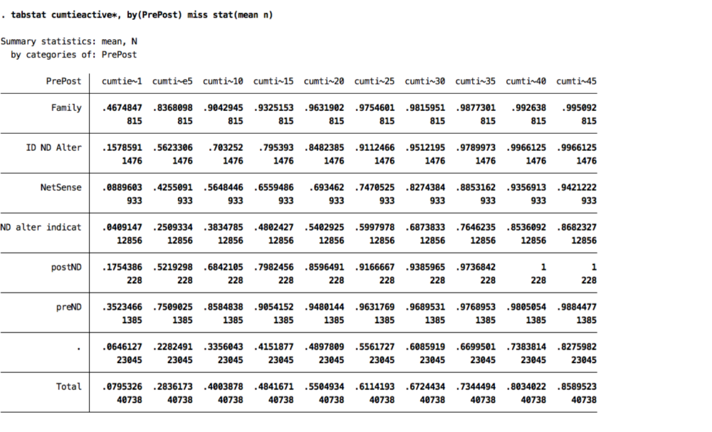

And this gives the same stats but in terms of when alter was named by ego (using the namedind variable).
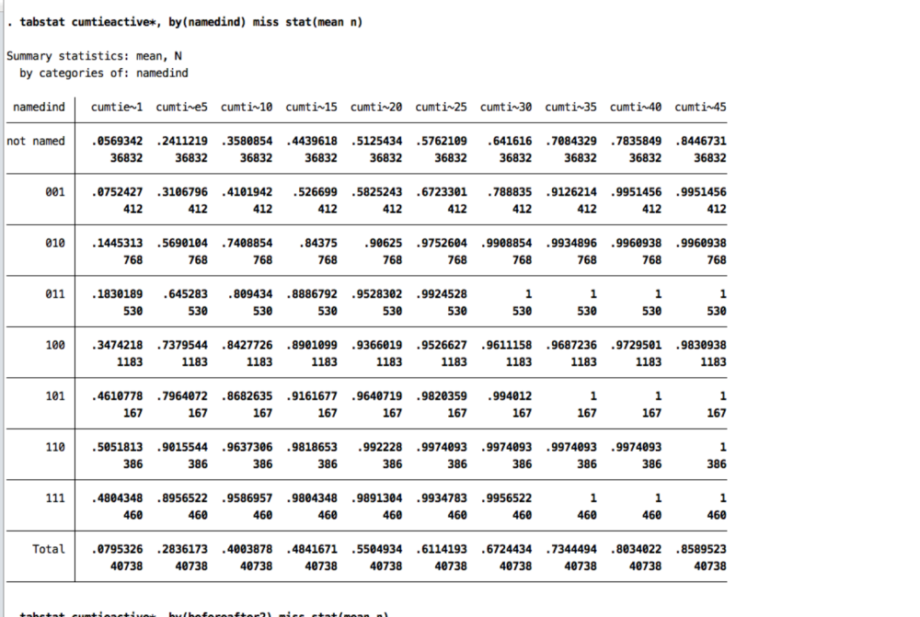

Analysis – Node Data

Here is the correlation matrix among all the various degree measures. Note that some of these correlations are “built in” because we are looking a co-variation among two variables that overlap. For example Degree_NDR includes Degree_NS. The difference variables are methodologically indepdendent, as are the family and preND variables.

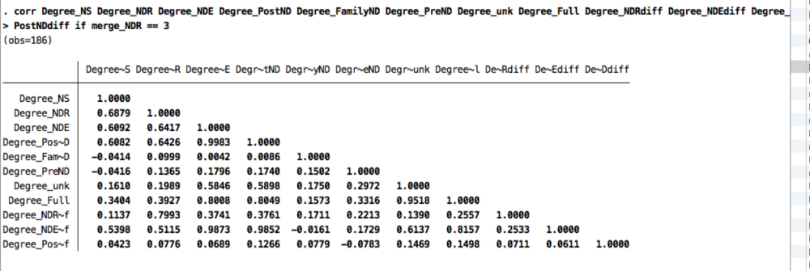
With these data we can do many things, but three stand out right now.

- See if we can predict full postND nodal degree from subset degrees, such as NetSense degree. This will tell us whether or not working with just the NetSense (or the ND Student Restricted) data would be biased.
- See if postND degree is correlated with preND and FamilyDegree
- Assess variation across NetSense participants in the composition of their networks.

Below is a simple regression for predicting postND degree by Family degree, PreND degree and NetSense Degree with an R² of .4. PostND degree is independent of family degree, but positively related to PreND degree, indicating the overall people with more friends prior to coming to ND have more ND student friends.

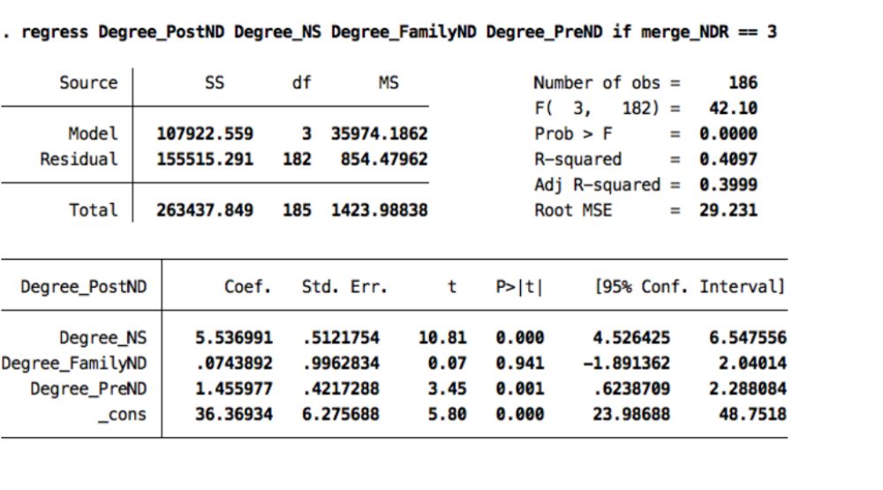

Here is another regression using instead Degree fro the restricted definition of ND student with a bit higher R² .

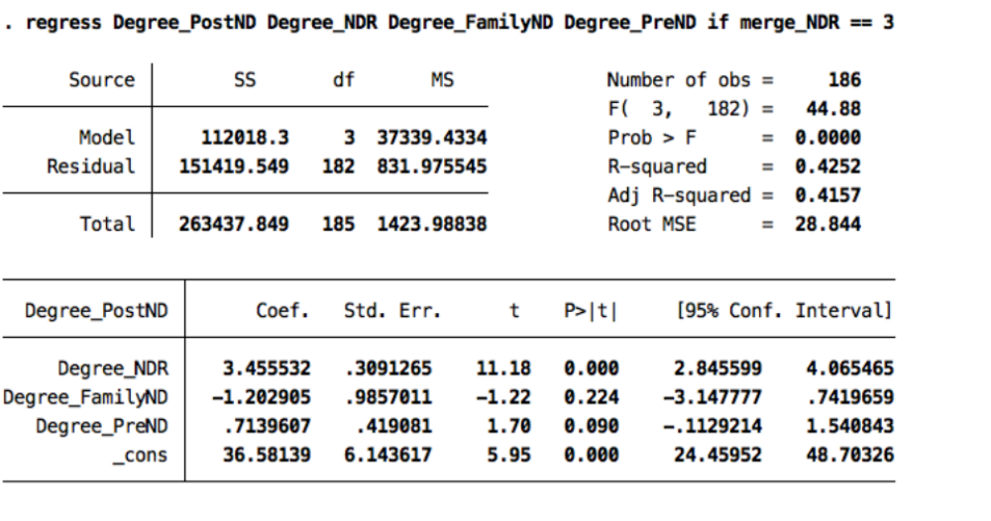
Both these regression have built in correlations given that the DV (Degree-PostND) includes Degree_NDR. We need to compute a net DegreePostND variable.

IN regards the ego network composition, here are the summary statistics giving the mean proportion across nodes of one of its alters falling in various categories (NetSense alter, Named Alter, Non ND post alter, Family, PreND alter, and unknown). These proportion are calculated based on the nodes full degree and sum to 1. On average, 55% of a NetSense subject’s alters are not identifiable, 31% identified as ND by Penta indicator, around 4% for both NetSense subject and named ND students, and 2% are family and about 4% pre ND friends.
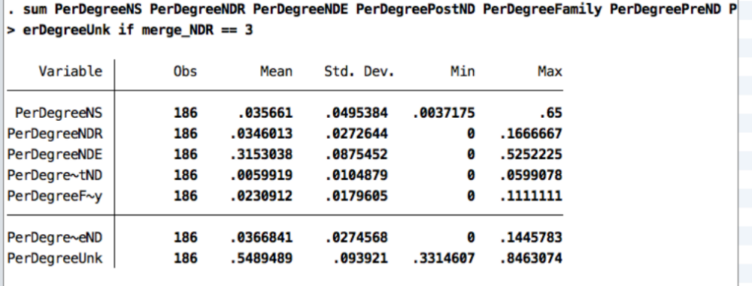

Here are these proportion but with the base being all the identifiable alters
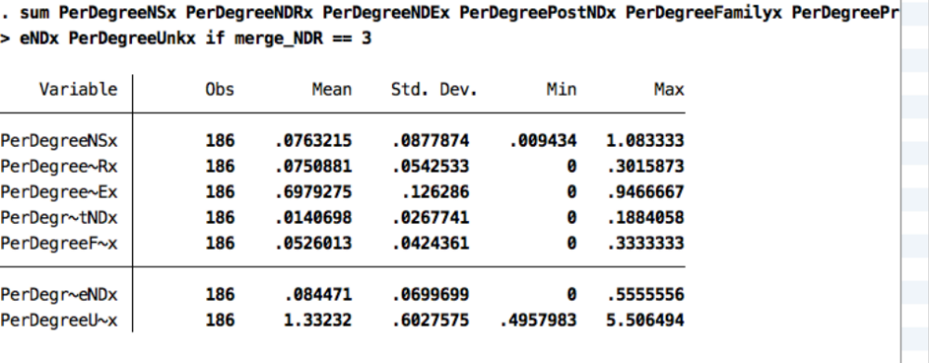
The last statistic is the ratio of the degree from known alters to the degree from unknown alters.

What would be interesting is to see if these proportions vary over time, as well as to examined variation across nodes in their network composition.

Note Penta generated some of these variables when created the master edge list, but they had to be redone. His variables are renamed with and suffix of “x”. Also cases are dropped from this edge list if they were named by an ego and thus on the alter list but no one in the study every communicated with them.
It seems strange that there are more edges than nodes, but note that this is like a bipartite graph in which there are 186 NetSense subjects who can have ties to about 700 family members, but each family member can only have 1 tie.

